### after quiz 1

Review of ‘**key**’:

* Superkey: a set of attributes such that no 2 tuples have the same values for these attributes
* Key/ candidate key: a minimal Superkey

If more than one:

* Primary key – one selected candidate key [only one]
* Secondary key – remaining candidate key
* Prime attribute: an attribute that is a member of any candidate key (need to find all the candidate key)
* Non-prime attribute: an attribute that is not a member of any candidate key

**Normalization**

* A process that aims at achieving better designed relational database schemas using functional dependencies and primary keys
* The normalization process takes a relational schema through a series of tests to certify whether it satisfies certain conditions
* ‘**Normal Form**’ – the schemas that satisfy certain conditions
* Unsatisfactory schemas are decomposed by breaking up their attributes into smaller relations that possess desirable properties (e.g. no anomalies)

**Normal form** (better design)

First normal form (1NF)

* A relation schema is in 1NF (first normal form) if domains of attributes include only atomic (simple/ indivisible/ individual) values and the value of an attribute is a single value from the domain of that attribute
* Disallows:

Having a set of values, a tuple of values, or a combination of both as an attribute value for a single tuple

‘Relations within relations’ and ‘relations as attributes of tuples’

(easier to query, and easier to scale – larger amount of data capture)

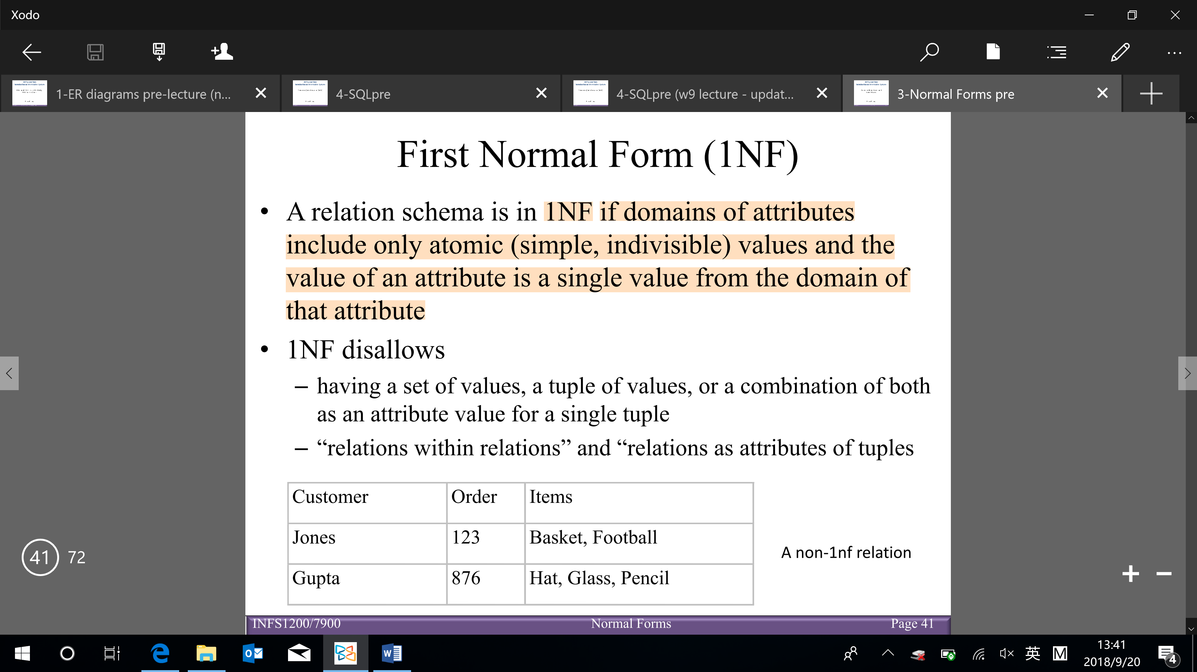

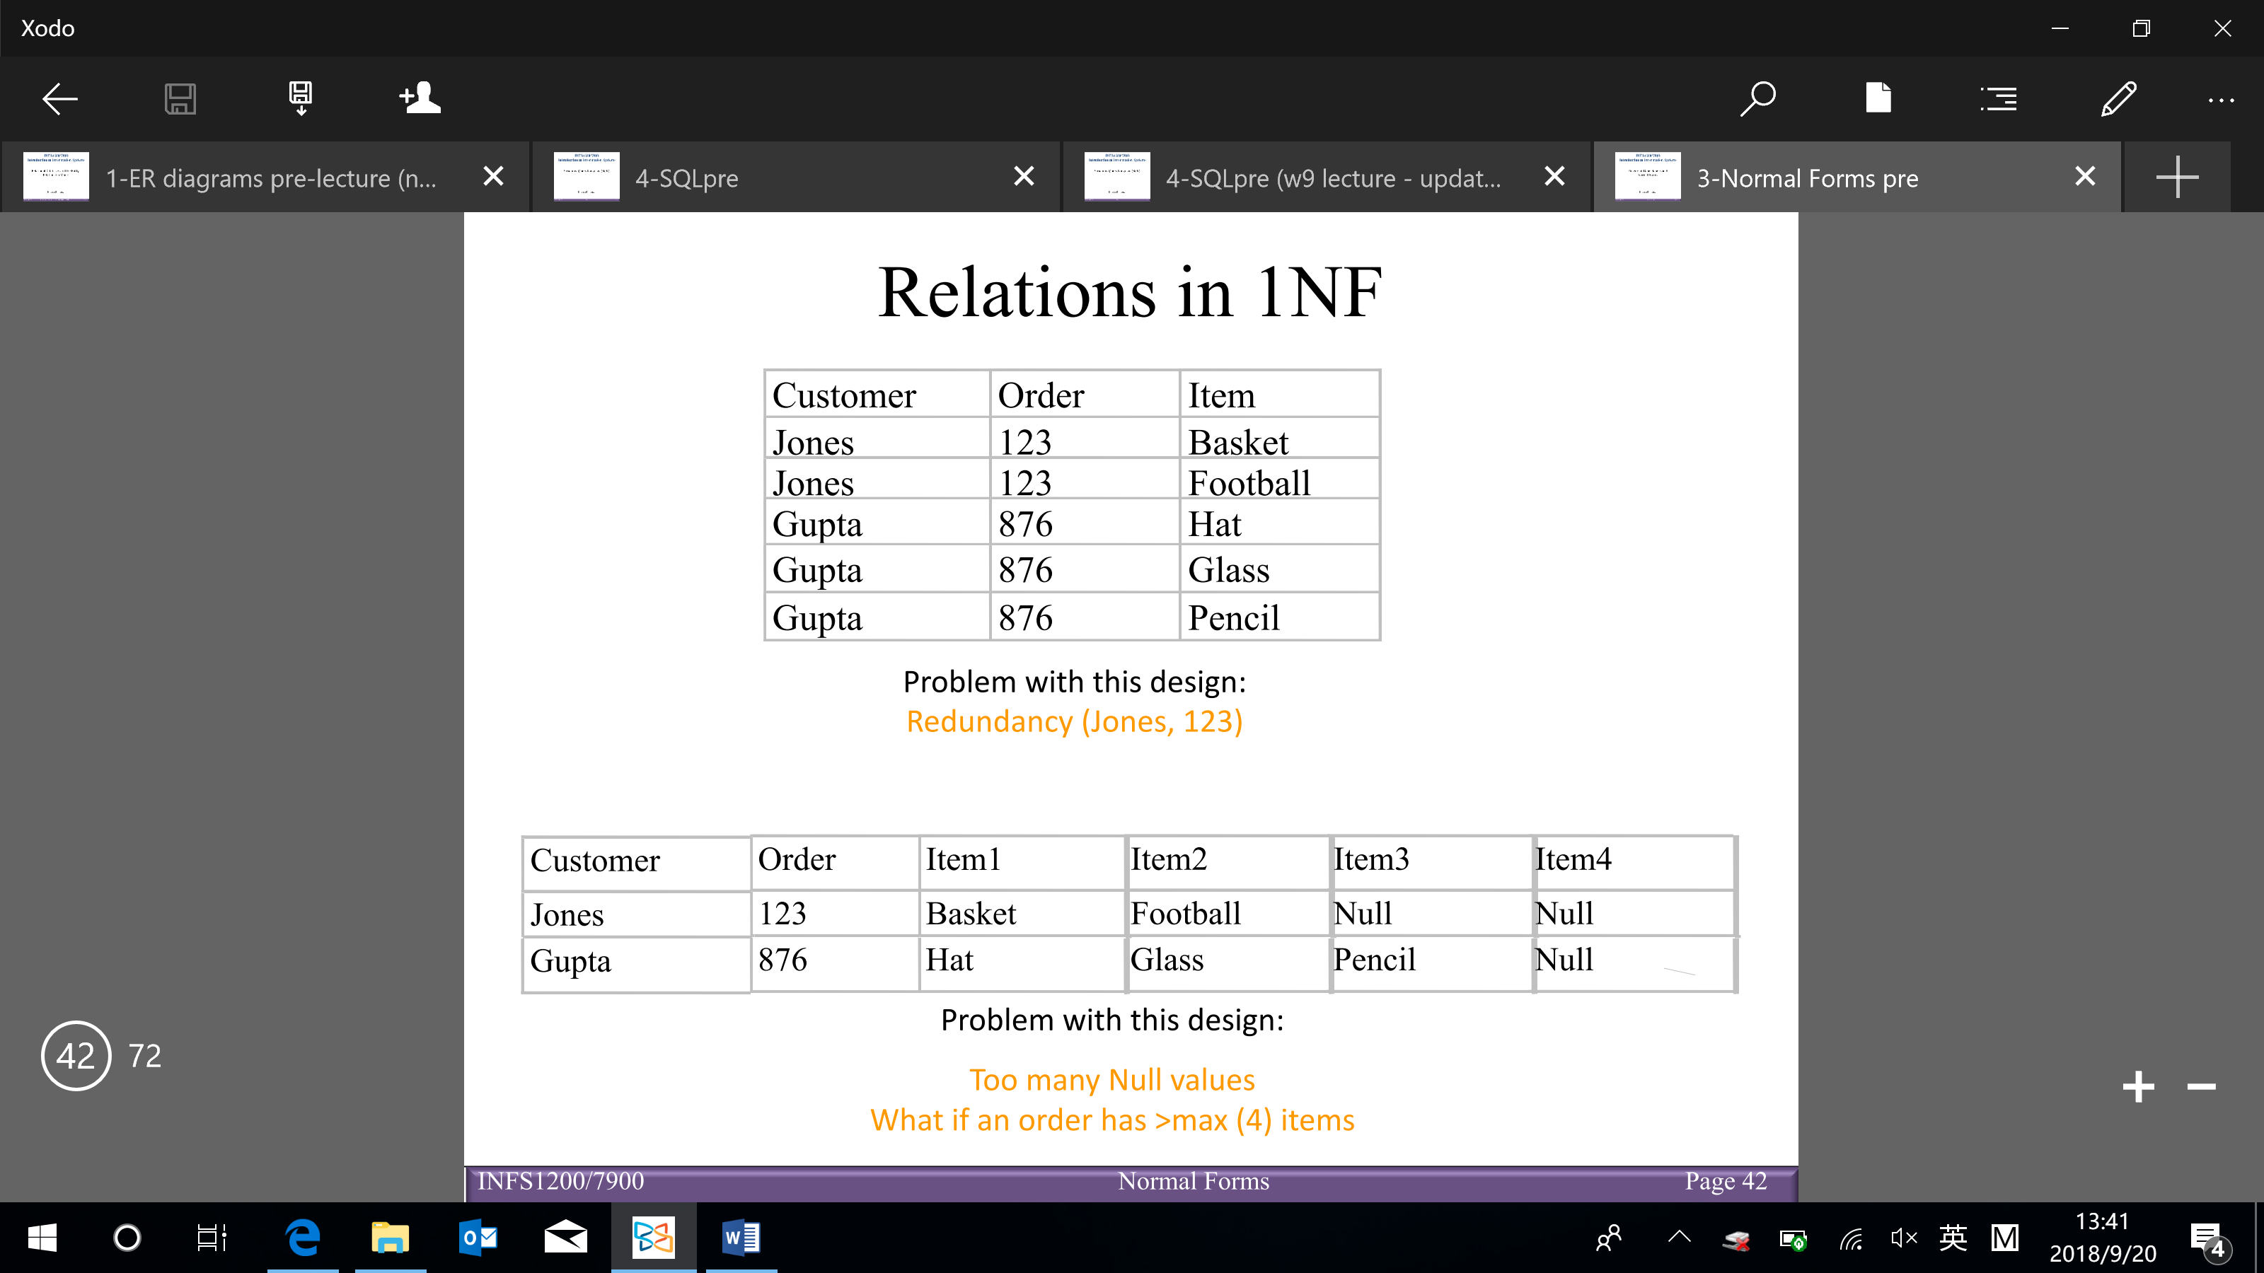

Second normal form (2NF)

* A relation is in 2NF, if for every FD: X → Y where X is a minimal/candidate key and Y is a non-prime attribute, then no proper subset of X determines Y

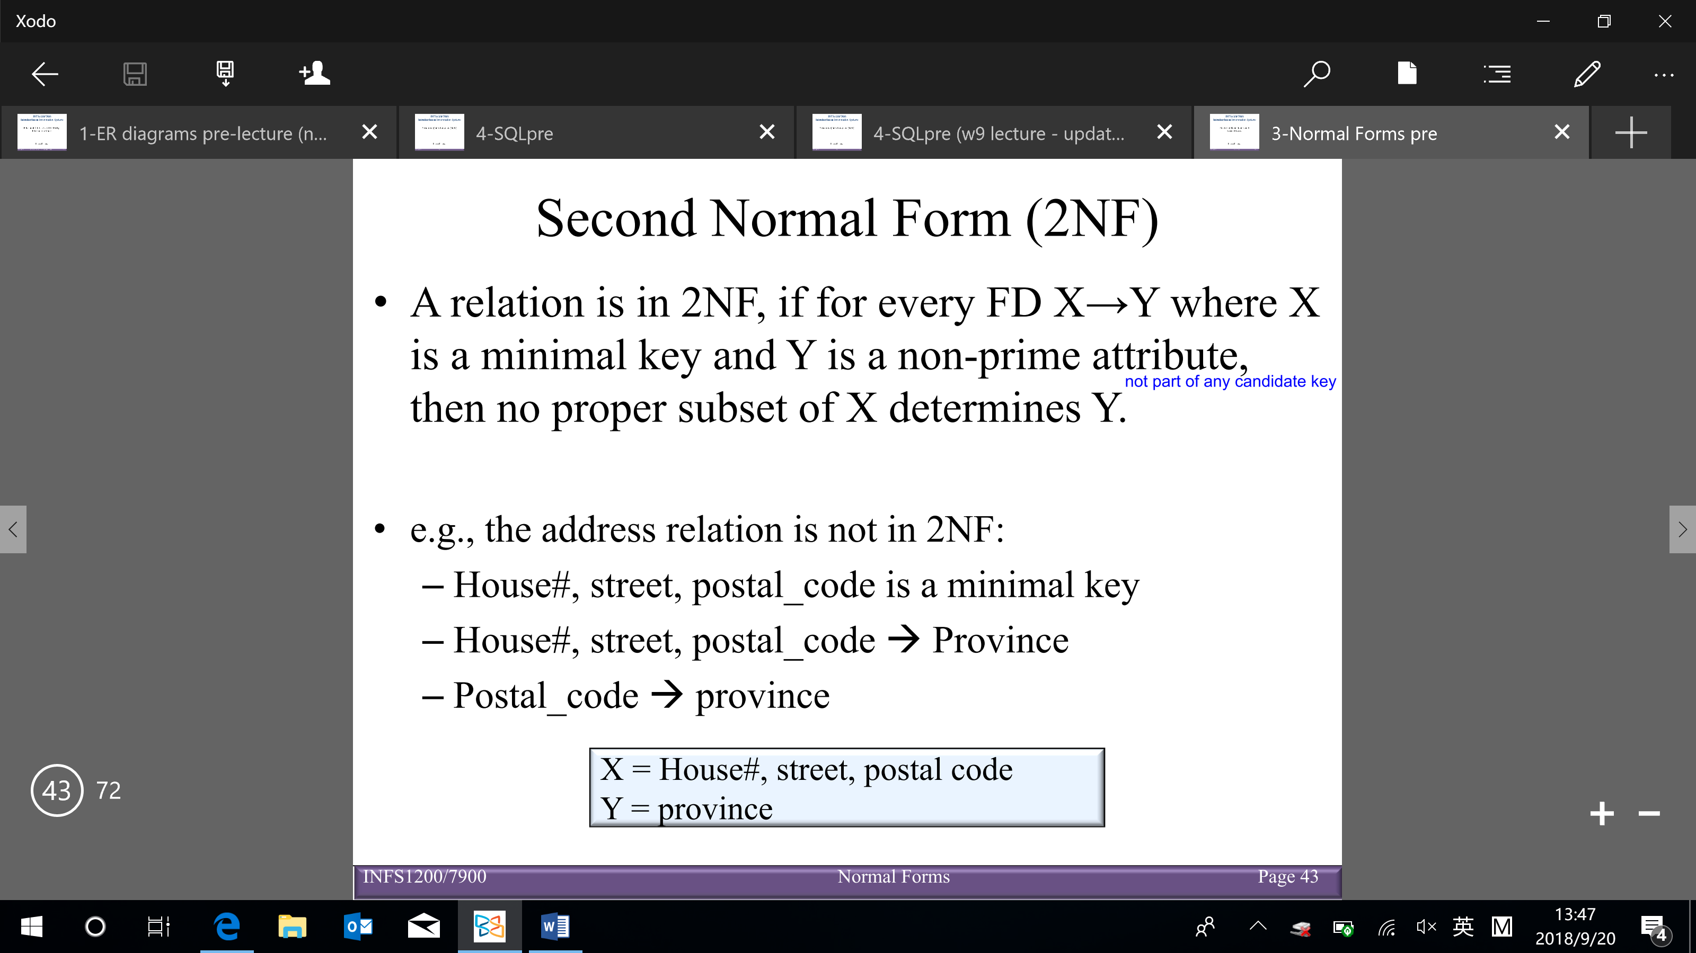

Boyce-Codd normal form (BCNF)

* A relation R is in BCNF if for all non-trivial dependencies in R: if X → b (and b is not the subset of X), then X is a Superkey for R

(whenever a set of attributes of R determine another attribute, it should determine all the attributes of R)

Trivial: if a FD: X → Y holds where Y is a subset of X (the LHS is contained RHS), then it is called a trivial FD

e.g. city, province → city

Non-trivial: if a FD: X → Y holds where Y is not the subset of X, then it’s a non-trivial FD

Completely non-trivial

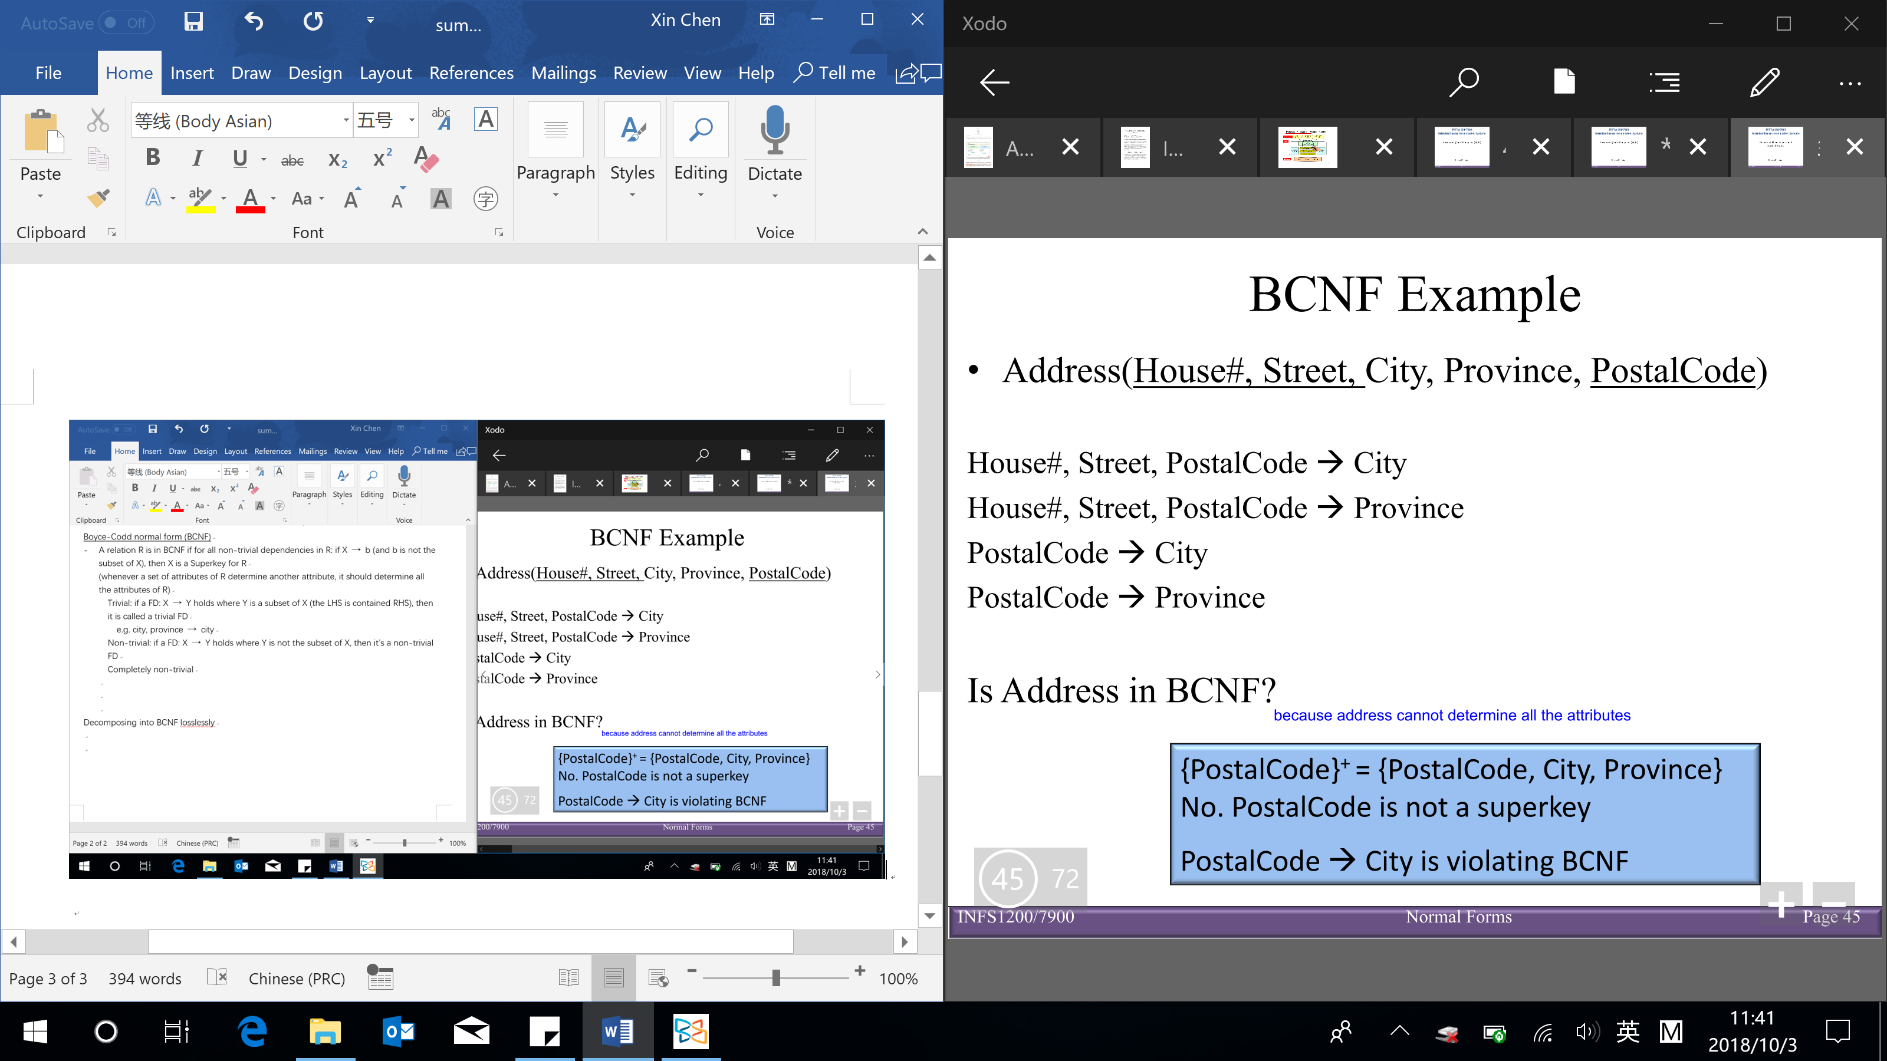

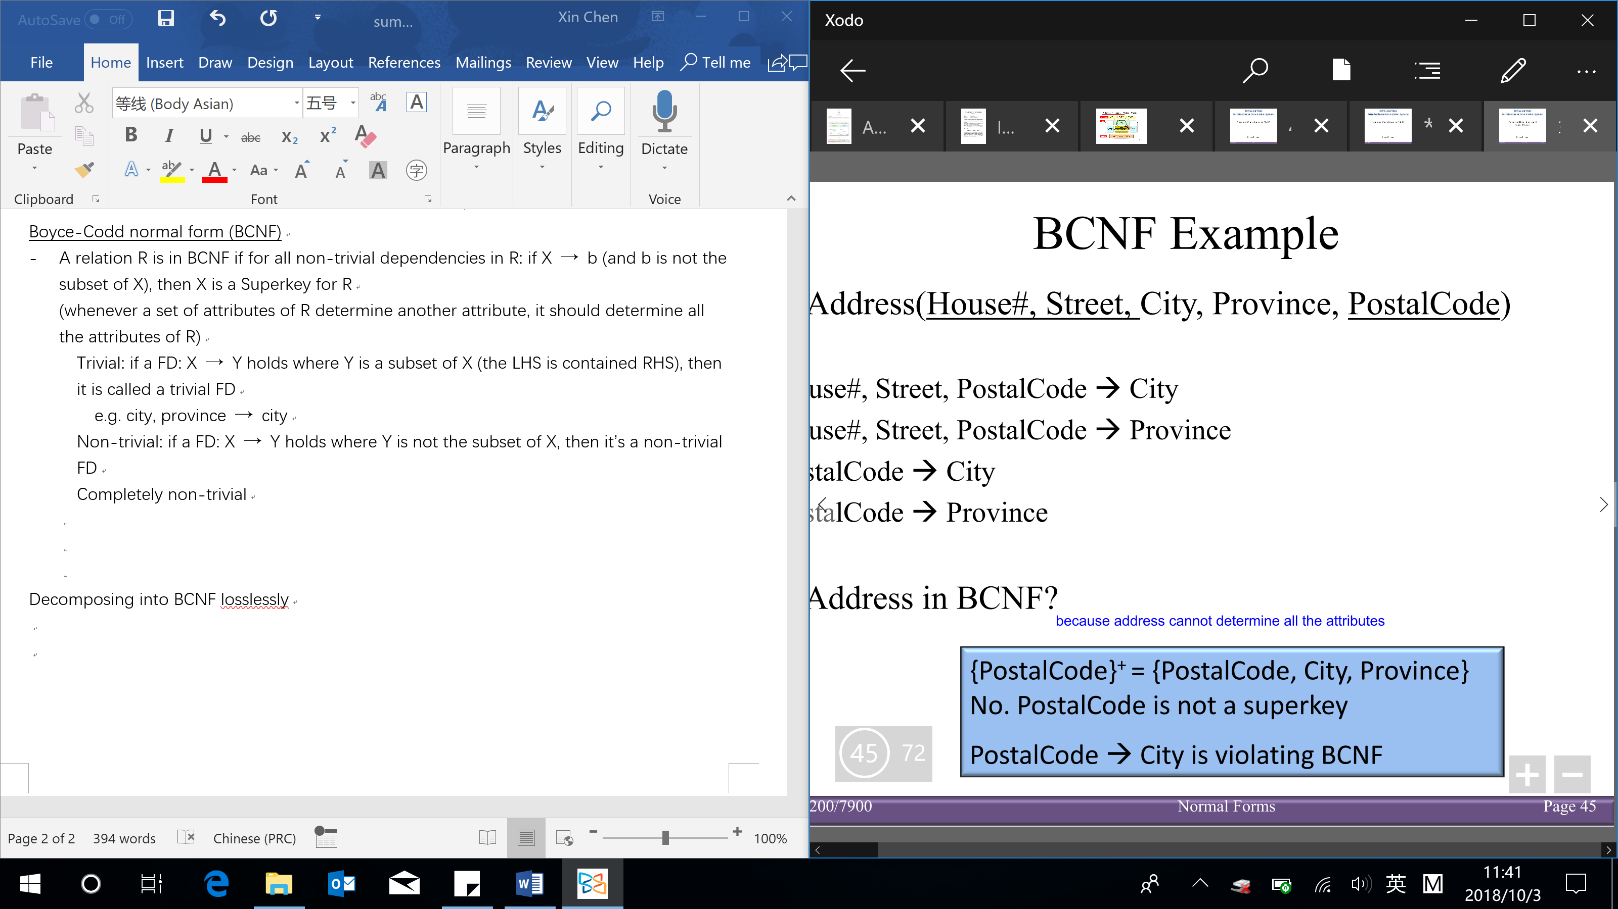

Decomposing into BCNF losslessly (4 steps):

[if join the decomposed table back together, it won’t have additional tuples and can reduce anomalies]

1. Add implicit FDs to your list of FDs

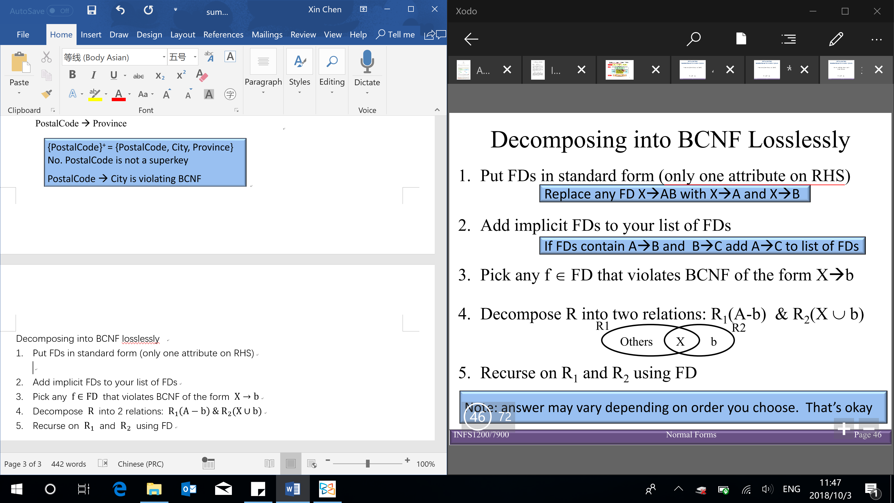

1. Pick any $f∈FD$ that violates BCNF of the form $X→b$ (if not violate BCNF, then stop the decomposition)
2. Decompose $R$ into 2 relations: $R_{1}\left(A-b\right) \& R_{2}(X∪b)$

(X and b are in one table, and everything except b are in another table)



1. Recurse on $R_{1}$ and $R_{2}$ using FD

(recursively do the steps 3 – 5 until no longer any of the table you have is violating BCNF)

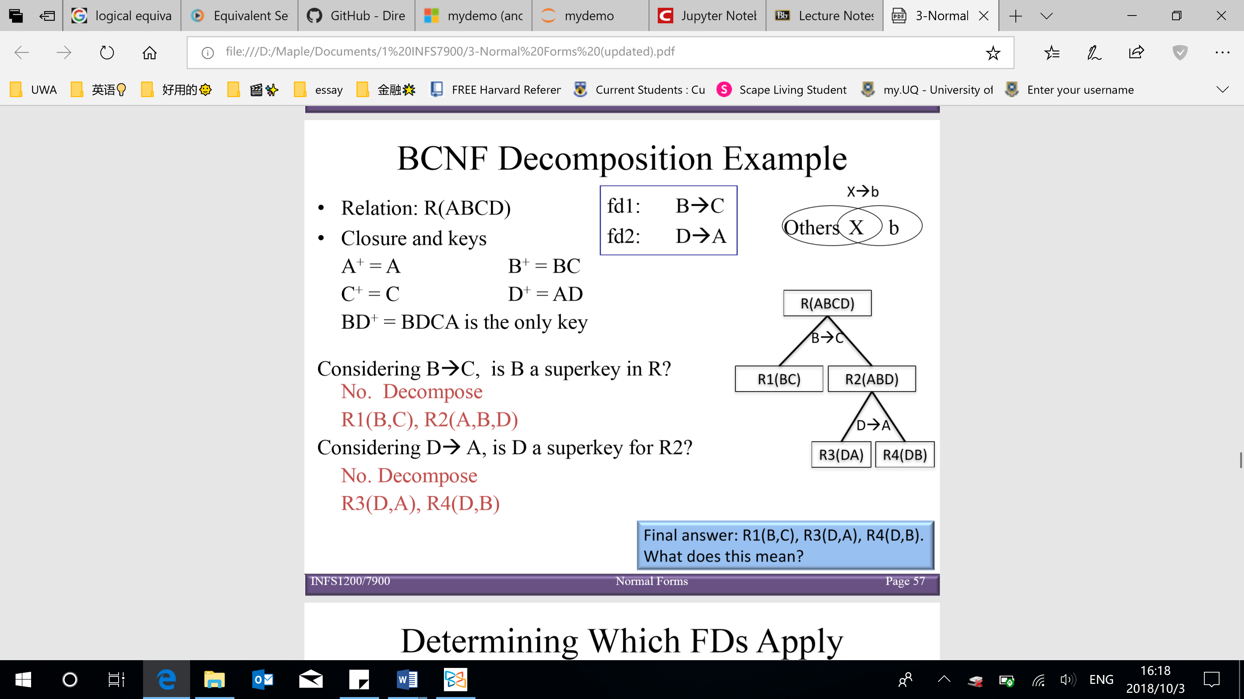

(First step: checking the closure of LHS → if it’s not a Superkey, violate the BCNF → decompose & finding the candidate/minimal key to check (not need to find all, but it’s necessary to find all the candidate key when decompose into 3NF))

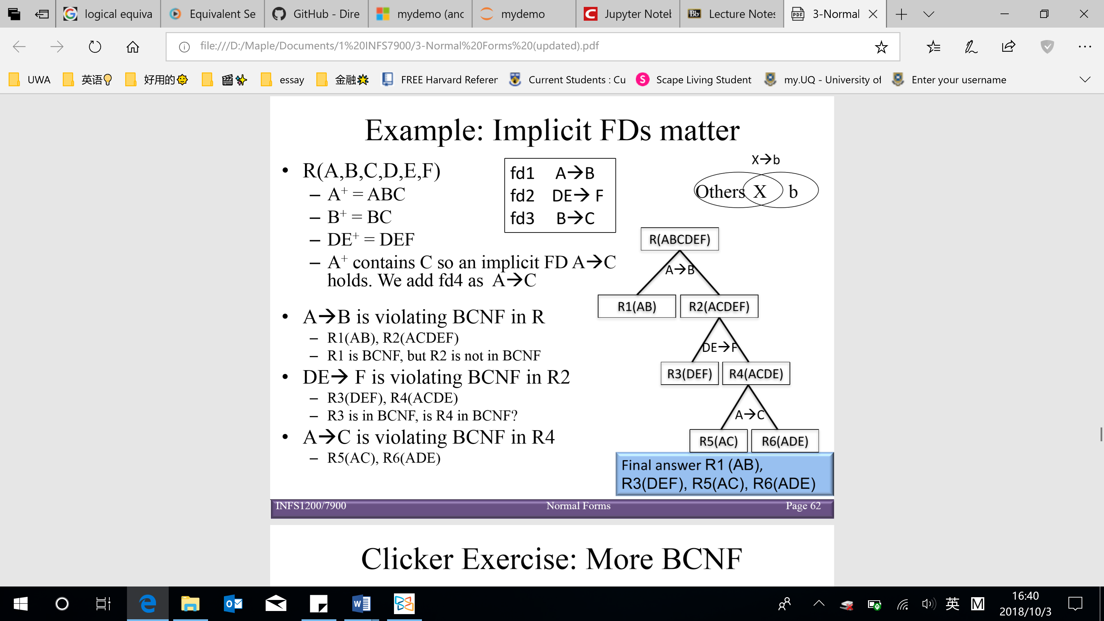

[Note: any table with only 2 attributes is in BCNF

4 possibility of a relation with only 2 attributes, which all are not violate BCNF

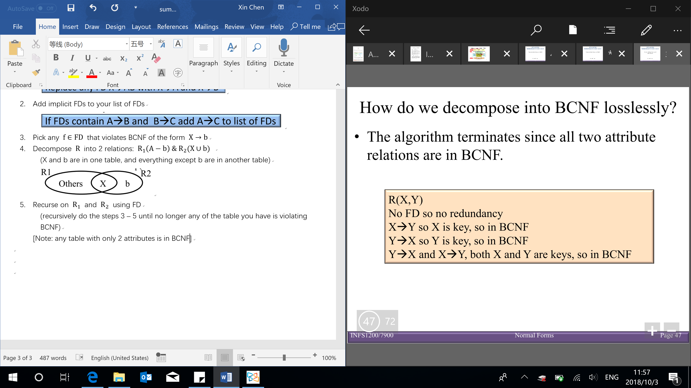

For any $FD X→b$, if the decomposed relation $S$ contains $\{X∪b\}$, and $b∈X^{+}$, then the FD holds for $S$

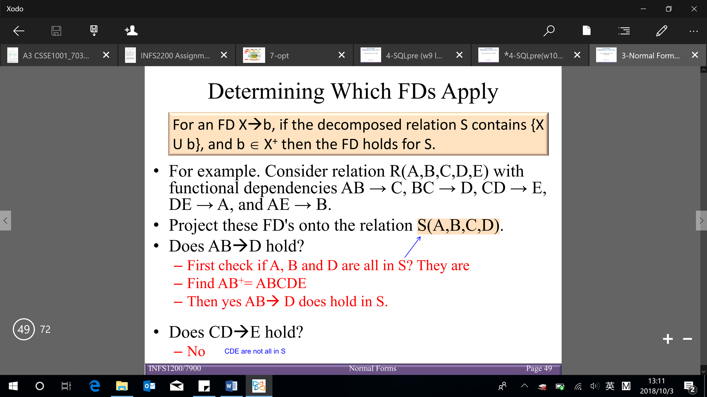]

BCNF

Advantages:

Guaranteed that there will be no redundancy of data – minimize the redundancy

Easy to understand (just look for superkeys)

Easy to do

Disadvantage:

May not preserve all dependencies

Dependency preservation

* A functional dependency $X→Y$ is preserved in a relation $R$, if $R$ contains all of the attributes of $X$ and $Y$

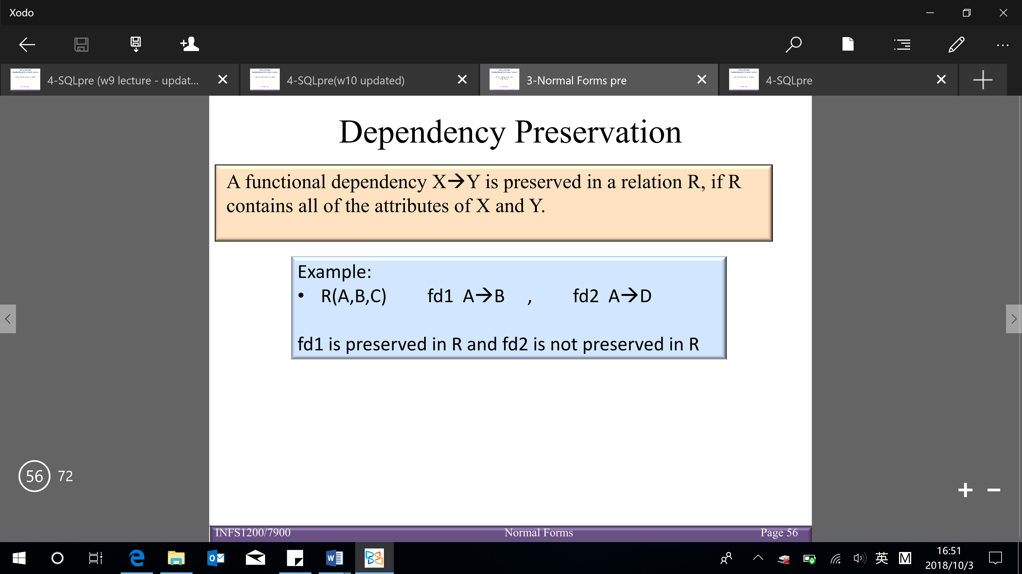

Don’t have a table such that have all of the attributes in FD2: company, product, unit

(for don’t having a table with all attributes of FD2 in one table, it’s hard to check the violation of FD2 when join back into a single table again)

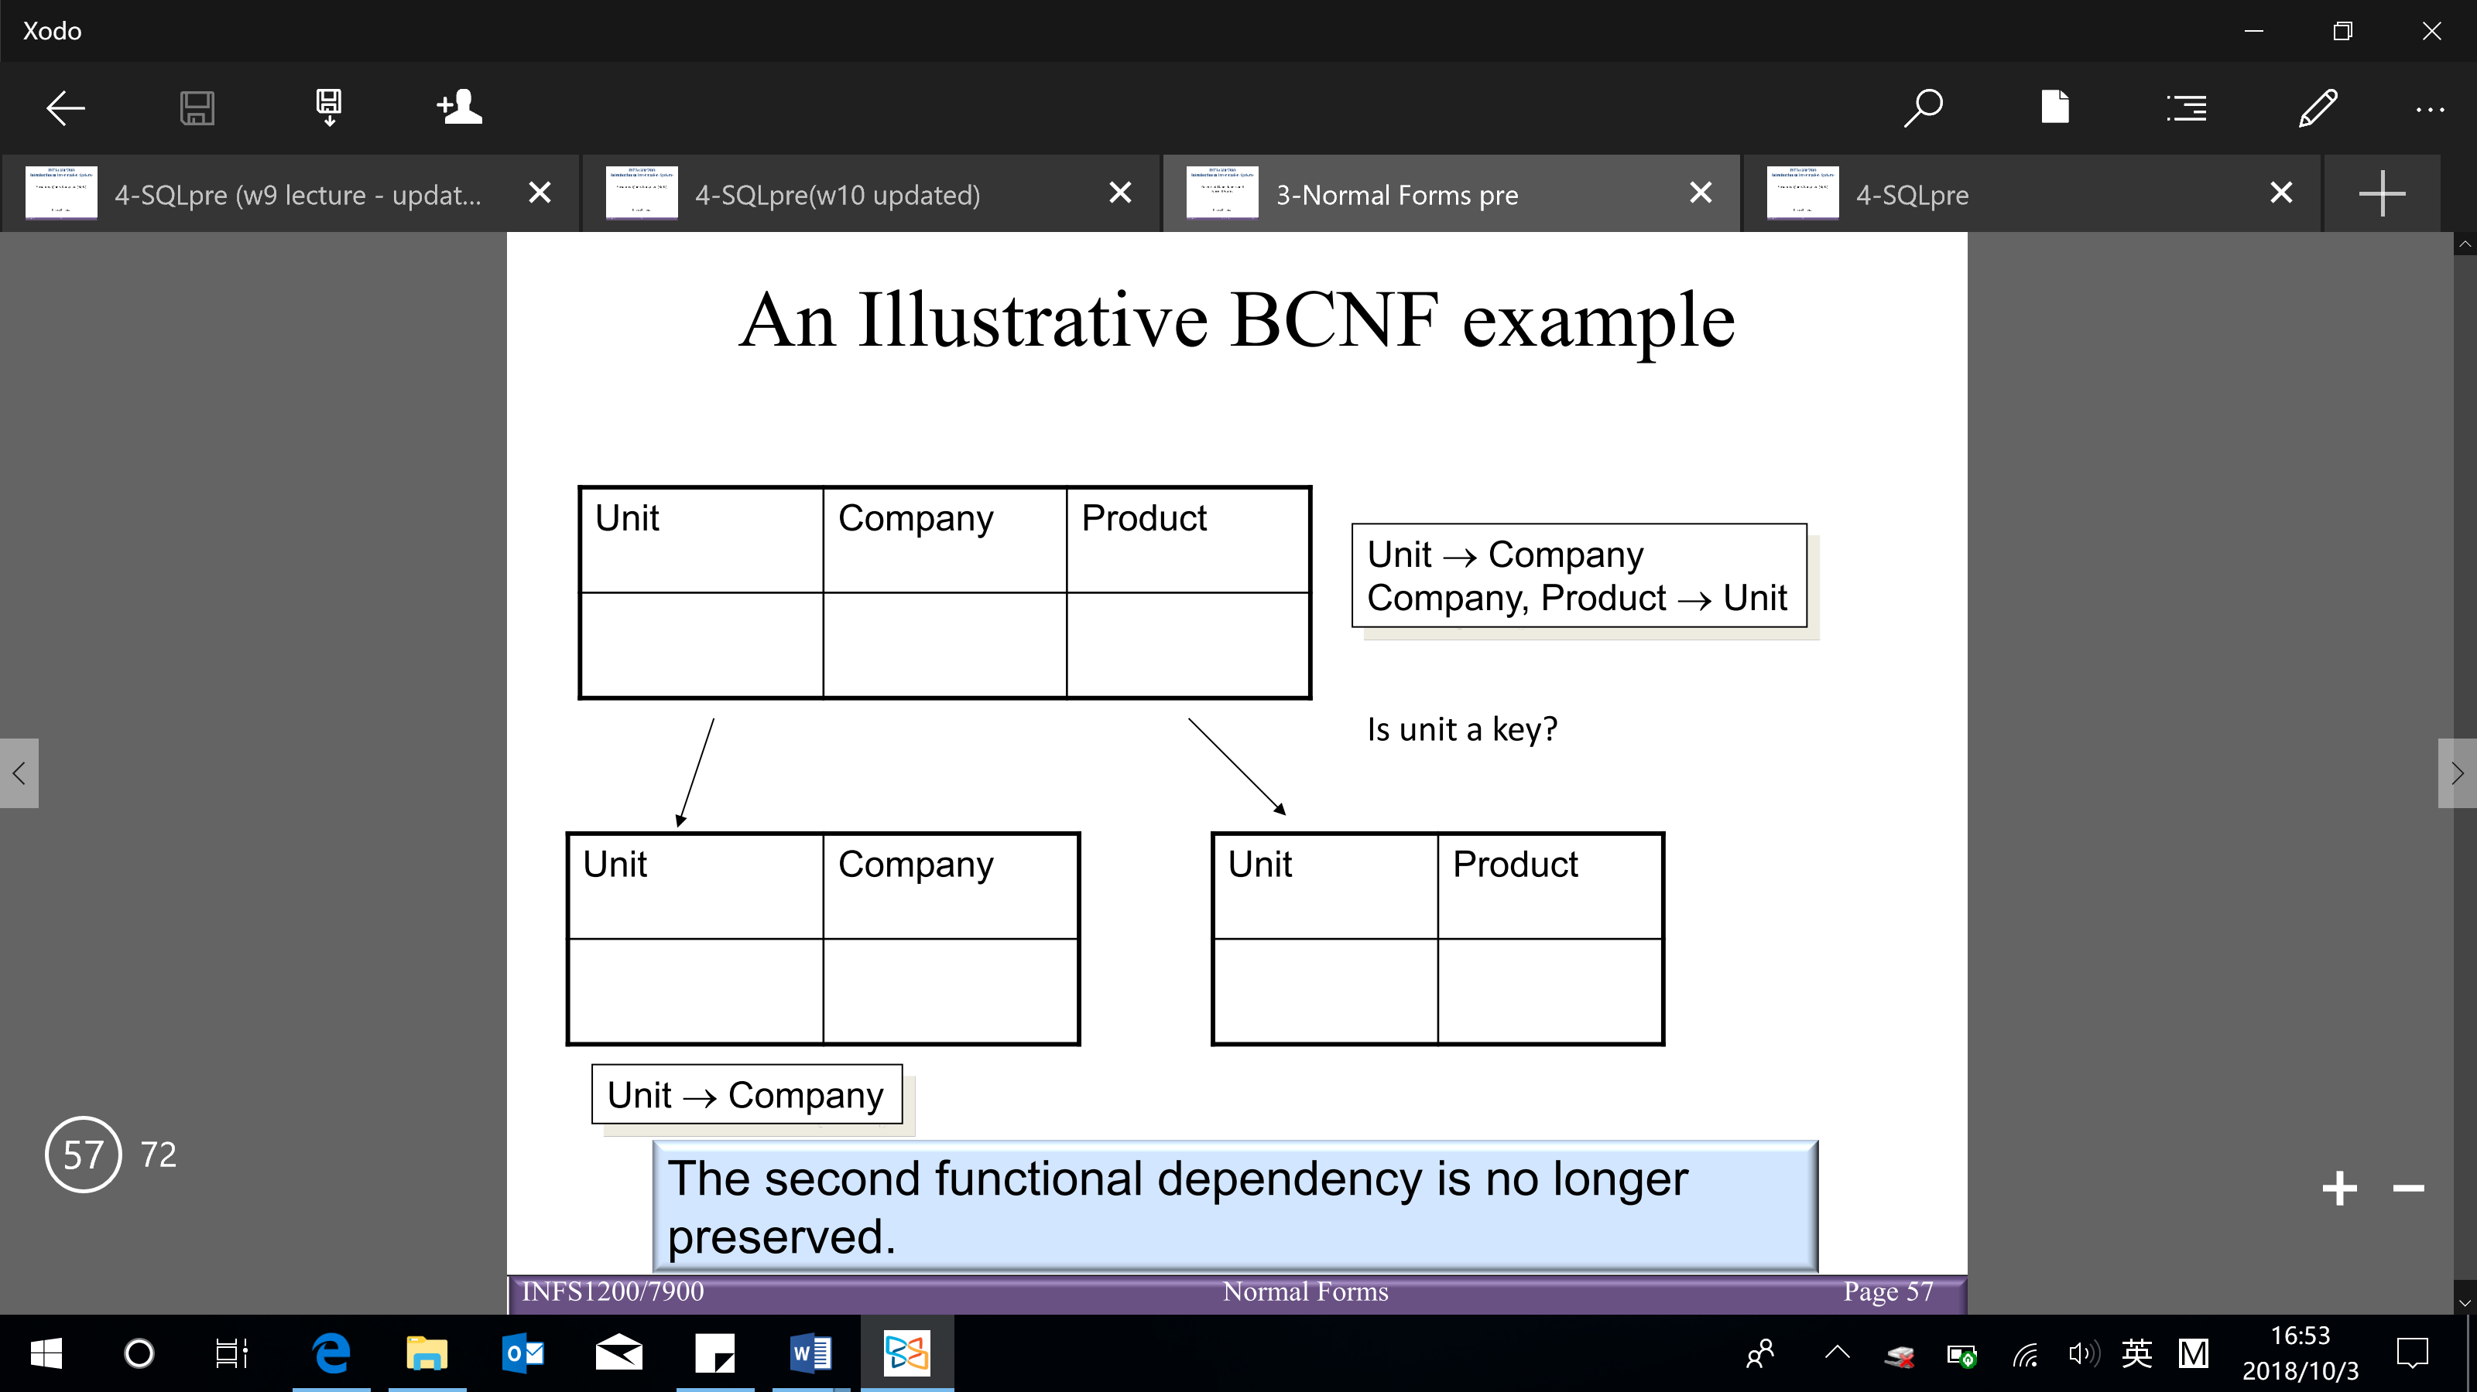

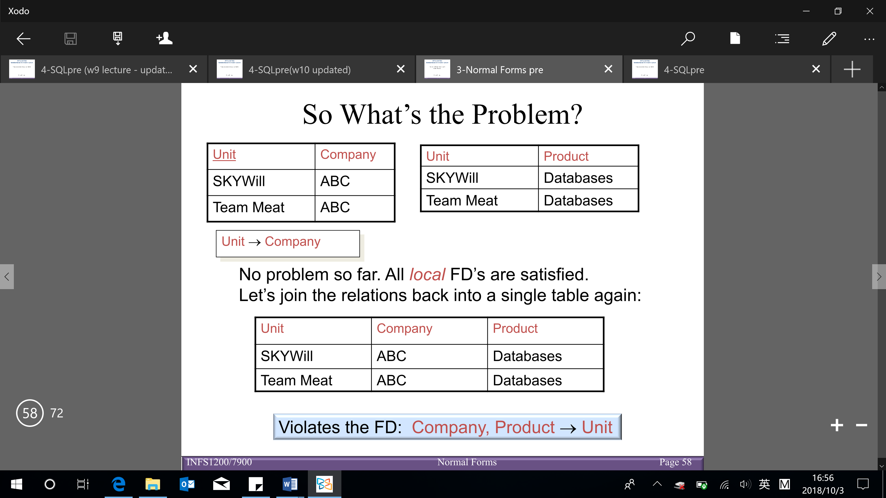

Third normal form (3NF)

* A relation R is in 3NF if for all non-trivial dependencies in R: if $X→b$ then

X is a Superkey for R (BCNF in so far)

OR b is a prime attribute of R (3NF – need to find all the candidate keys)

To decompose into 3NF rely on the minimal cover

Minimal cover $G$ for a set of FDs $F$:

[Goal: transform FDs to be as small as possible (every FD in G is needed, and is ‘as small as possible’ in order to get the same closure as F)]

* $Closure of F=closure of G$ (closure of everything in G and F are the same)
* $RHS of each FD$ in G is a single attribute (put FDs in standard form)
* If we delete an $FD in G$ or delete attributes from an FD in G, the closure changes

Finding minimal covers of FDs (3 steps – must do in the order):

1. Put FDs in standard form (have only one attribute on RHS)
2. Minimize LHS of each FD

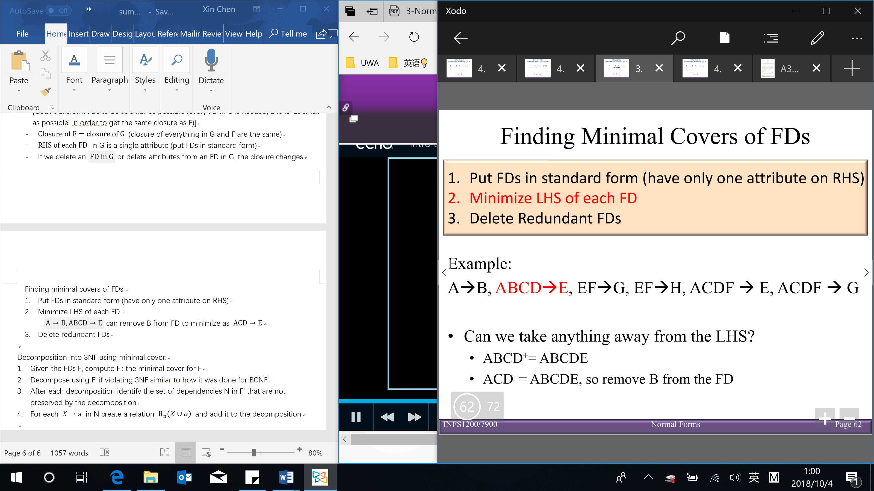

1. Delete redundant FDs (take a row out, check whether the closure are the same without considering that row → if the closure is the same, then delete)

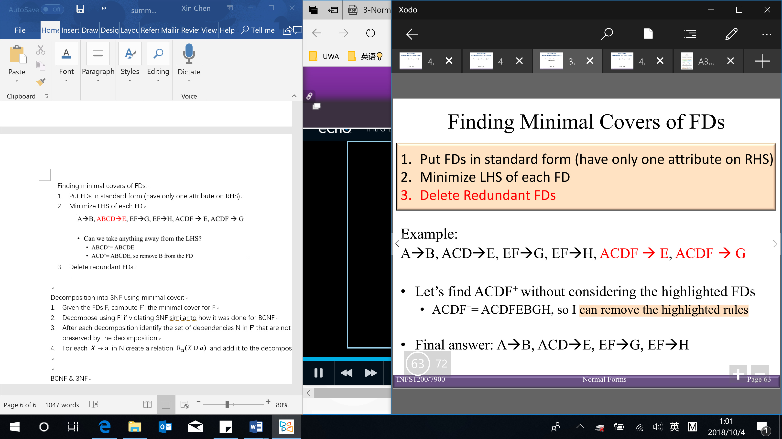

Decomposition into 3NF using minimal cover:

1. Given the $FDs F$, compute $F^{'}$– the minimal cover for $F$

& need to find all the candidate keys

1. Decompose using $F^{'}$ if violating 3NF similar to how it was done for BCNF

Decompose $R$ into 2 relations: $R_{1}\left(A-b\right) \& R_{2}(X∪b)$

1. After each decomposition, identify the set of dependencies N in $F^{'}$ that are not preserved by the decomposition → then need to add those relations back
2. For each $X→a$ in N create a relation $R_{n}\left(X∪a\right)$ and add it to the decomposition

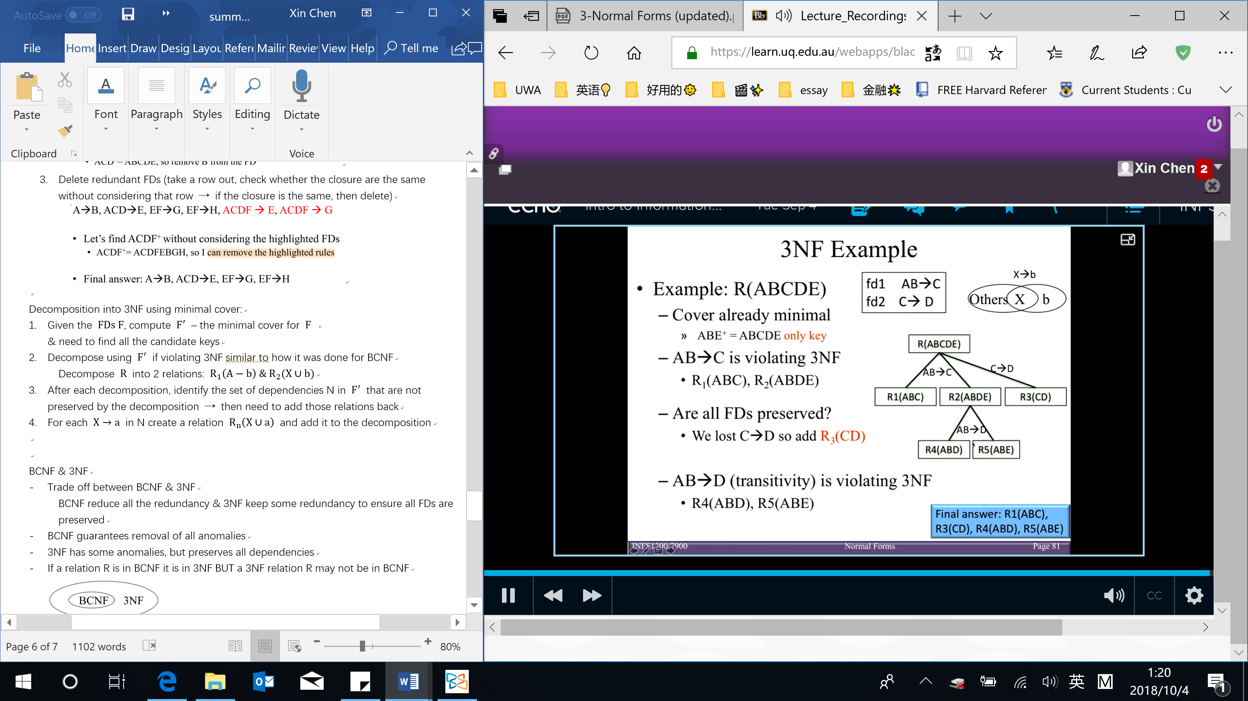

BCNF & 3NF

* Trade off between BCNF & 3NF

BCNF reduce all the redundancy & 3NF keep some redundancy to ensure all FDs are preserved

* BCNF guarantees removal of all anomalies
* 3NF has some anomalies, but preserves all dependencies
* If a relation R is in BCNF it is in 3NF BUT a 3NF relation R may not be in BCNF

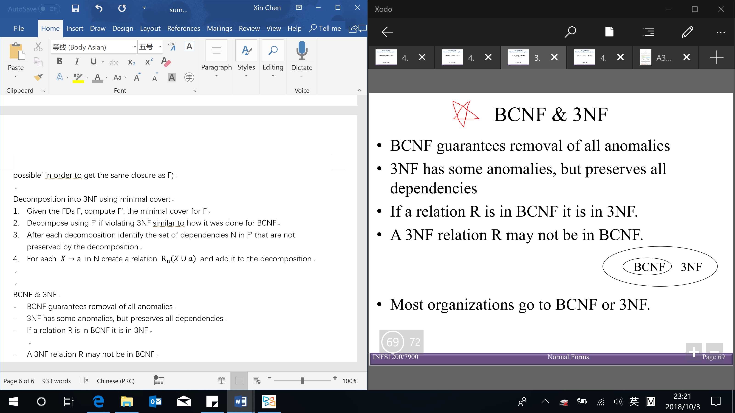

* Most organizations go to BCNF or 3NF (both are industry standard)

Denormalization

* Process of intentionally violating a normal form to gain performance improvements

Performance improvements (improve the running time):

* Fewer joins
* Reduces number of foreign keys
* Useful in data analysis or if certain queries often require (joined) results, and the queries are frequent enough (data normally are not dynamic, e.g. data in database)